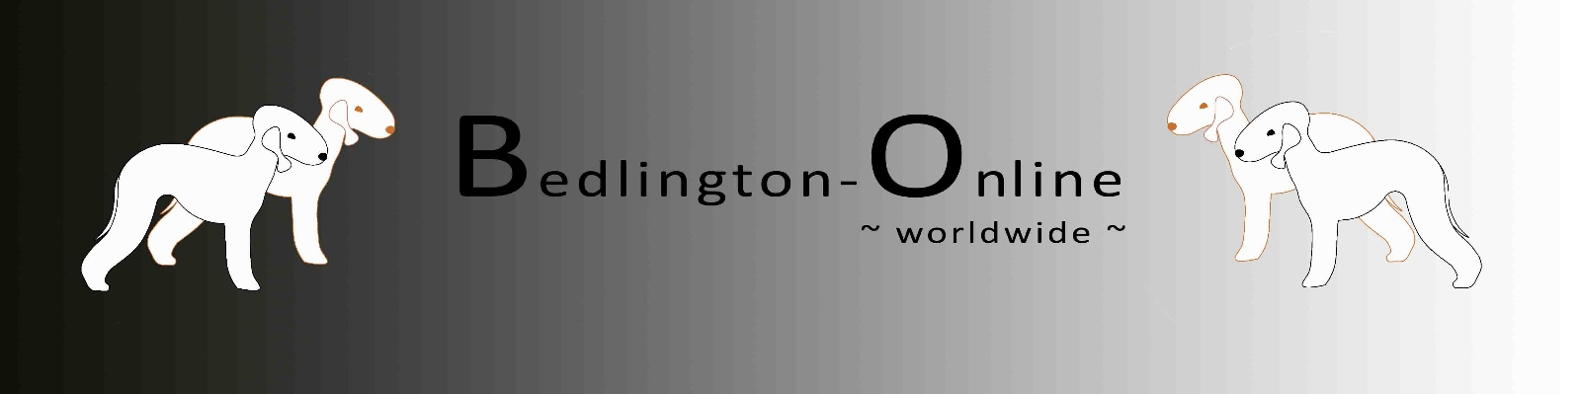

Application for admission a Kennel
on the Website „Bedlington-Online.com“

Kennel: | Text
Breeder: | Text |  |  |  | (Name, City, Country)
Phone: | Telefonnr. | E-Mail: | Text
Website: | Text | Facebook: | Text | (Name)

Please send this form to the following E-Mail-Adress: info@bedlington-online.com

Changes can be made anytime.

With my signature I confirm that all of the above information is correct. I also give my consent that the aforementioned information may be published on the website www.bedlington-online.com (administered by Nina Bläser, Bochum). As soon as I no longer wish to be published, I will inform Miss Bläser about it.

City | Date
(City) | Date |  | Signature of the Breeder

